FORM F
UNIFORM MOTOR CARRIER BODILY INJURY AND PROPERTY DAMAGE LIABILITY INSURANCE ENDORSEMENT



Date:
Jeffrey A. Silver
Endorsement Effective:
Countersigned By:
Named lnsured:
(Authorized Representative)

It is agreed that:

- The certification of the policy, as proof of financial responsibility under the provisions of any State motor carrier law or regulations promulgated by any State Commission having jurisdiction with respect thereto, amends the policy to provide insurance for automobile bodily injury and property damage liability in accordance with the provisions of such law or regulations to the extent of the coverage and limits of liability required thereby; provided only that the insured agrees to reimburse the company for any payment made by the company which it would not have been obligated to make under the terms of this policy except by reason of the obligation assumed in making such definition.
- The Uniform Motor Carrier Bodily Injury and Property Damage Liability Certificate of Insurance has been filed with the State Commission(s) indicated below.
- This endorsement may not be cancelled without cancellation of the policy to which it is attached. Such cancellation may be affected by the company or the insured giving thirty (30) days' notice in writing to the State Commission with which such certificate has been filed, such thirty (30) days' notice to commence to run from the date the notice is actually received in the office of such Commission.

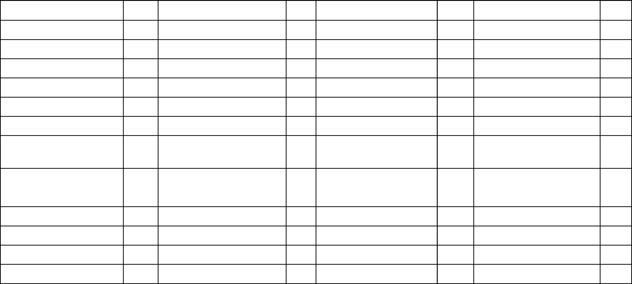
INDICATES STATE COMMISSIONS WITH WHOM UNIFORM MOTOR CARRIER BODILY INJURY AND PROPERTY DAMAGE LIABILITY CERTIFICATE OF INSURANCE HAS BEEN FILED

ALABAMA | ILLINOIS | MONTANA | RHODE ISLAND
ALASKA | INDIANA | NEBRASKA | SOUTH CAROLINA
ARIZONA | IOWA | NEVADA | SOUTH DAKOTA
ARKANSAS | KANSAS | NEW HAMPSHIRE | TENNESSEE
CALIFORNIA | KENTUCKY | NEW JERSEY | TEXAS
COLORADO | LOUISIANA | NEW MEXICO | UTAH
CONNECTICUT | MAINE | NEW YORK | VERMONT
DELAWARE | MARYLAND | NORTH CAROLINA | VIRGINIA
DISTRICT OF | MASSACHUSETTS | NORTH DAKOTA | WASHINGTON
COLUMBIA
FLORIDA | MICHIGAN | OHIO | WEST VIRGINIA
GEORGIA | MINNESOTA | OKLAHOMA | WISCONSIN
HAWAII | MISSISSIPPI | OREGON | WYOMING
IDAHO | MISSOURI | PENNSYLVANIA

